TITLE PAGE
TECHNICAL REPORT ON STUENTS INDUSTRIAL WORK EXPERIENCE SCHEME (SIWES)

AT
MECHANICAL ENGINEERING DEPARTMENT, GOVERNMENT TECHNICAL COLLEGE, ABAKPA, OGOJA, CROSS RIVER STATE

FROM: 6TH OCTOBER, 2023
TO: 29TH JANUARY, 2024

BY
IJOKO, SOLOMON AJAP
(ET/ME/ND/22/054)

THIS TECHNICAL REPORT IS SUBMITTED IN PARTIAL FULFILMENT OF THE REQUIREMENTS FOR THE AWARD OF NATIONAL DIPLOMA (ND) IN MECHINICAL ENGINNERING TECHNOLOGY, FEDERAL POLYTECHNIC MUBI.

JULY, 2024.

CERTIFICATION
This report written by Ijoko Solomon Ajap with registration number ET/ME/ND/22/054 was certified and approved by the following

SIWES Supervisor _____________ _____________
Engr. Sunday Zechariah Sign Date

SIWES Coordinator _____________ _____________
Dr. Mohammed Bashir A. Sign Date

Head of Department _____________ _____________
Mr. Cosmos Tizhe Sign Date

DEDICATION
This work is dedicated to my beloved parents for leading me into intellectual pursuit by giving me the financial support, in addition to the enormous contribution (financially and morally) made by my brothers and family members.

ACKNOWLEDMENT
All glory be to God almighty the creator of heaven and earth for his sufficient grace throughout the period of my SIWES program and I thank God for giving this great opportunity.
I will like to show my appreciation to my HOD Mr. Cosmos Tizhe, My SIWES Supervisor and all staff of Mechanical Engineering Federal Polytechnic Mubi, Adamawa state of Nigerian.
I also acknowledge and thank Engr Ojong Ojong Eyam, my industrial supervisor for his dedication, concern and contribution during the period of my SIWES program.
I would also like to express my infinite thanks to the entire management and staff of Government Technical College for honoring me and accepting my application and helpful relation accorded to me during the period of my attachment.
Finally, I also thank my family, friends and relative for supporting me morally and financially throughout my education and successful completion of my student industrial work experience scheme (SIWES) program.

SUMMARY
This technical report comprises of four (4) chapters. Chapter one comprises of Introduction to SIWES, History of SIWES, Aim and Objectives of SIWES, chapter two comprises of Maintenance of Lathe and Drilling Machine, Measurement and Marking out, marking out tools, cutting and hand tools, Chapter Three contains welding operation, Type of welding, Construction of an Oven, Construction of Window Protector, Construction of Fufu pounder, Chapter four comprises of the Conclusion and the Recommendation on the SIWES.

TABLE OF CONTENT

TITLE PAGE i
CERTIFICATION ii
DEDICATION iii
ACKNOWLEDMENT iv
SUMMARY v
TABLE OF CONTENT vi
CHAPTER ONE 1
1.1 Brief History of SIWES 1
1.2 Aims and objectives of SIWES 2
1.3 Brief history of organization 2
1.4 Organizational Chart of Government Technical College, Ogoja 3
CHAPTER TWO 4
MAINTENANCE OF LATHE AND DRILLING MACHINES 4
2.1 Maintenance of Lathe Machine 4
2.2 Maintenance of Drill Machine 5
2.2 Measurements and marking out 6
2.3 Marking Out Tools 7
2.4 Cutting and work holding tools: 8
CHAPTER THREE 10
3.1 Welding Operation 10
3.1.1 Type of work carried out using oxy-acetylene 10
3.1.2 Procedure followed to cut a metal plate 10
3.1.3 Electric arc welding 10
3.1.4 Setting up for arc welding 11
3.1.5 Drilling on the machine 11
3.1.6 Drilling of a 40mm diameter round work piece 11
3.2 Fabrication of Fufu pounder 12
3.3 Construction and Fabrication of an Oven 13
3.4 Construction of Window Protector 16
3.5 Construction and Fabrication of Rice Thresher 18
CHAPTER FOUR 20
CONCLUSION AND RECOMMENDATION 20
4.1 Conclusion 20
4.2 Recommendation 20
REFERENCES 21

CHAPTER ONE

1.1 Brief History of SIWES
SIWES was founded in 1973 by ITF (Industrial Training Funds) to address the problem of tertiary institution graduates' lack of appropriate skills for employment in Nigerian industries. The Students' Industrial Work Experience Scheme (SIWES) was founded to be a skill training programme to help expose and prepare students of universities, Polytechnics and colleges of education for the industrial work situation to be met after graduation.
This system facilitates the transfer from the classroom to the workplace and aids in the application of knowledge. The program allows students to become acquainted with and exposed to the experience required in handling and operating equipment and machinery that are typically not available at their schools.
Prior to the establishment of this scheme, there was a rising concern and trend among industrialists that graduates from higher education institutions lacked appropriate practical experience for employment. Students who entered Nigerian universities to study science and technology were not previously trained in the practical aspects of their chosen fields. As a result of their lack of work experience, they had difficulty finding work.
As a result, employers believed that theoretical education in higher education was unresponsive to the needs of labor employers. Thousands of Nigerians faced this difficulty till 1973. The fund's main motivation for establishing and designing the scheme in 1973/74 was launched against this context.
The ITF (Industrial Training Fund) organization decided to aid all interested Nigerian students and created the SIWES program. The federal government officially approved and presented it in 1974. During its early years, the scheme was entirely supported by the ITF, but as the financial commitment became too much for the fund, it withdrew in 1978. The National Universities Commission (NUC) and the National Board for Technical Education (NBTE) were given control of the scheme by the federal government in 1979. The federal government handed over supervision and implementation of the scheme to ITF in November 1984. It was taken over by the Industrial Training Fund (ITF) in July 1985, with the federal government bearing entire responsibility for funding.

1.2 Aims and objectives of SIWES
The Industrial Training Fund’s Policy Document No. 1 of 1973 which established SIWES outlined the objectives of the scheme as:
- Provide an avenue for students in Institutions of higher learning to acquire industrial skills and experience in their respective courses of study.
- Prepare students for the Industrial Work situation they are likely to experience after graduation.
- Expose students to work methods and techniques of handling equipment and machinery that may not be available in their Institutions.
- Make the transition from school to the world of work easier; and enhance students’ networks for later job placements.
- Provide students with an opportunity to apply their knowledge to real work situations, thereby bridging the gap between theory and practice; and vi. Enlist and strengthen Employers’ involvement in the entire educational process; thereby preparing the students for employment in Industry and Commerce.

1.3 Brief history of organization
The mechanical engineering department at Government Technical College Abakpa, Ogoja, Cross River State, was established to support students transitioning from secondary education to higher studies in mechanical engineering. Founded in 2000, the department is equipped with advanced machinery and tools aimed at providing students with comprehensive practical knowledge. Students undertaking their SIWES (Students Industrial Work Experience Scheme) in the department have consistently reported significant learning experiences, enhancing their understanding and readiness for higher education in mechanical engineering.

1.4 Organizational Chart of Government Technical College, Ogoja
PRINCIPAL
VICE PRINCIPAL ADMINISTRATION
VICE PRINCIPAL ACADEMIC
STAFFS
STUDENTS
HEAD OF DEPT.
STUDENTS
SIWES STUDENT

Figure 1.1: Organizational Chart

CHAPTER TWO

MAINTENANCE OF LATHE AND DRILLING MACHINES

2.1 Maintenance of Lathe Machine
2.1.1 Problem
The tailstock of the lathe machine was not moving properly, which can hinder the precision and efficiency of machining operations.

2.1.2 Tools/Equipment
Hydraulic Oil, Foam, and Spanner.

2.1.3 Procedure/Steps
  - Dipped a piece of foam into hydraulic oil.
  - Thoroughly cleaned the tailstock and surrounding areas with the oil-soaked foam to remove any dirt, debris, and old lubricant that might be causing the tailstock to stick.
  - Used a spanner to carefully loosen the bolt and nut of the tailstock.
  - Applied hydraulic oil to all moving parts within the tailstock to ensure proper lubrication.
  - After cleaning and lubrication, reassembled the tailstock.
  - Used the spanner to tighten the bolt and nut to their appropriate torque settings, ensuring the tailstock is secure yet able to move smoothly.

2.1.4 Precaution
  - After reassembly, manually moved the tailstock to ensure it could move freely without any sticking or resistance.
  - Verified that all bolts and nuts were tightened to the correct specifications to avoid any loose parts during operation.
  - Checked that the hydraulic oil was adequately applied and no excess oil was left on the machine surfaces to prevent slipping hazards.

2.2 Maintenance of Drill Machine

2.2.1 Problem
The spindle of the drill machine was not rotating smoothly, causing issues with drilling accuracy and efficiency.

Tools/Equipment
Lubricating Oil, Foam, and Spanner

2.1.3 Procedure/Steps
- Thoroughly cleaned the spindle and surrounding areas with the oil-soaked foam to remove any dirt, debris, and old lubricant that might be causing the spindle to stick.
- Used a spanner to carefully loosen the bolts and nuts of the spindle assembly.
- Applied lubricating oil to all moving parts within the spindle to ensure proper lubrication.
- After cleaning and lubrication, reassembled the spindle.
- Used the spanner to tighten the bolts and nuts to their appropriate torque settings, ensuring the spindle is secure yet able to rotate smoothly.
- Turned on the drill machine and tested the spindle’s rotation to ensure it was smooth and free of any irregular movements.
- Adjusted the lubrication to achieve optimal performance.

2.1.4 Precaution
- After reassembly, manually rotated the spindle to ensure it could move freely without any sticking or resistance.
- Verified that all bolts and nuts were tightened to the correct specifications to avoid any loose parts during operation.
- Checked that the lubricating oil was adequately applied and no excess oil was left on the machine surfaces to prevent slipping hazards.

2.2 Measurements and marking out
Measuring tools are very important tool in engineering. I always carried out measurement when jobs were given to me to fabricate in the workshop.
The measuring tools I used were:
- The Vernier Caliper
- The micrometer depth gauge
- The engineering steel tape
- The engineering steel rule
- Vernier Caliper: I used the Vernier caliper to measure and gauge the external and internal diameter of bars and tubes and shafts to get an accurate dimension in fig2c.
  - I took reading of the Vernier caliper which number of millimeter on the main scale to the left of zero of the Vernier scale are added. The number of 0.02mm on the Vernier scale coincide with a line on the main scale.
- The Micrometer Depth Gauge: I used the micrometer depth gauge to measure depth of holes and slots.
- The Engineering Tape: I used the engineering tape to measure the length of a rod, shaft that are long length.
- The Engineering Steel Rule: I used the engineering steel rule which is graduated in centimeters and inches to measure the length of a short work piece.
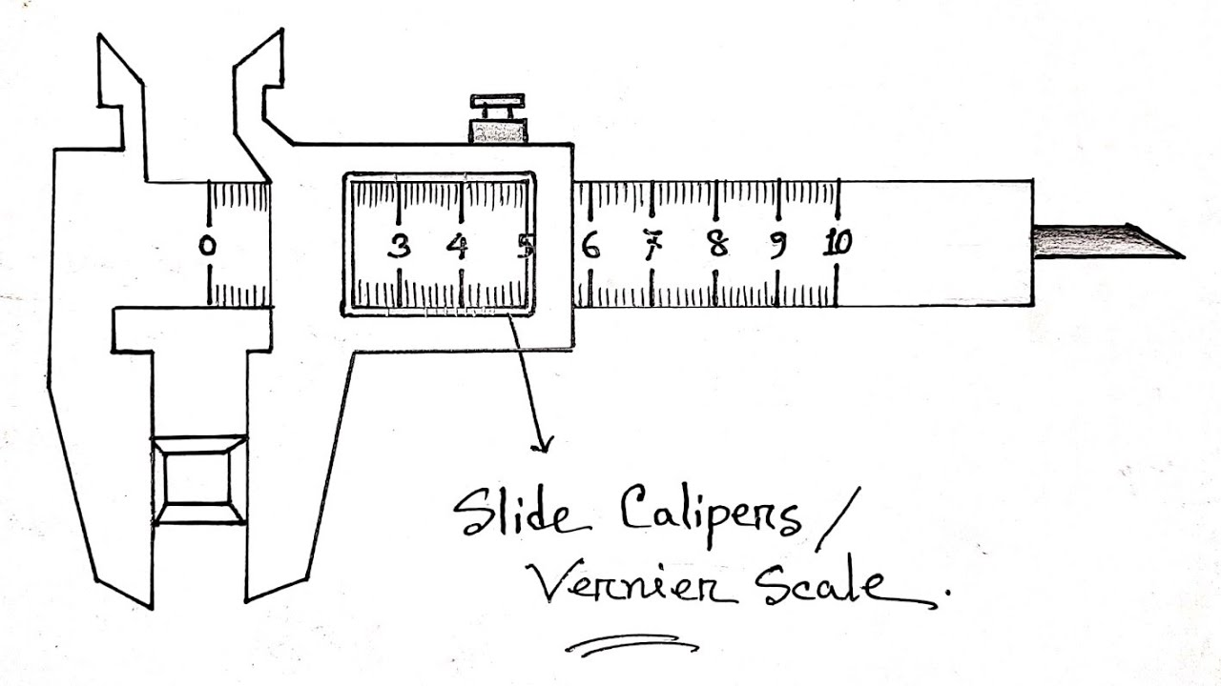
Figure 2.1: Vernier Caliper

2.3 Marking Out Tools
Marking out tools are simple equipment I used in the work shop for tiny indentation, scratch, cribbing marking, locating the dividing on a work piece before operation. These tools are:
- Centre punch
- The scriber
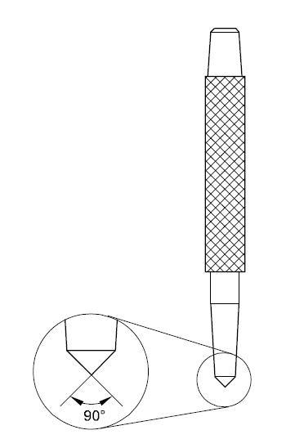
- The pair of dividers
- The try square
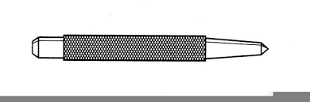
- The dot Punch

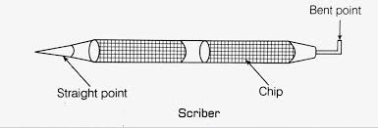

Figure 2.2: Marking out tools
- The center punch: The center punch is marking out tool, I used it to mark, or locate a center before drilling, either on a circle etc. this is to create a point on the work piece of that the drill bit would not wobble when introduced to the work. As shown in fig.2a.
- The scriber: The scriber is an engineering marking out tool simply called an engineering pencil, I used it to draw lines or scribe out a required like on the metal work piece. As shown in fig. 2b.
- The pair of divider: I used the pair of divider for marking out circle arcs, and radii, and for transferring measurements from engineering rate to work piece.
- THE TRY SQUARE: I used the try square in setting out lines at right and testing surfaces at 90ºeach other before carried out.

2.4 Cutting and work holding tools:
Cutting tools are available tools necessary in the workshop for their application for the cutting, chipping, sawing. drilling etc. they are made both of manual and electric machine in various size and with adaptors to such different application.
- The hack saw: I used the hacksaw for cutting off length of material to required dimension and sometimes used it to trim off.
- Files: I used a file when a fair amount of metal requires removal and I used the file to carry out finishing when working to fine limits i.e. for a good and smooth finish as shown in fig.3b. before. I carried out filling on a work piece, I make sure that the work was firmly clamped or held on a vice and the working surface as near as possible to the vice jaw, to prevent the work from vibrating and pull out.
- Chisels: I used chisels to cut cold metals or other designed parts on a work piece and plates
- The cross-cut chisel: I used the cross cut chisel to cut grooves such as slot, channels and keyways shown in fig,2c.
- The flat chisel: I used the flat chisel to cut sheet and plate metals and removing surplus metal from surface.
- Holding tool: I used holding tool to hold together pieces of work while marking out, filling, cutting, drilling and removing nuts from the bolts such holding tools are engineer’s vice, hand drill machine vice, hand vice and pliers.
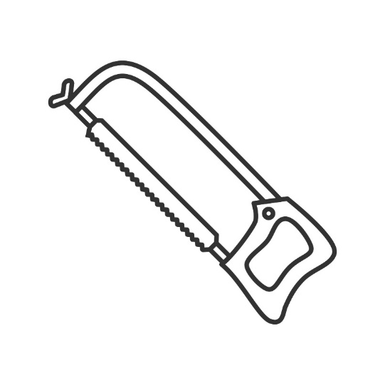
Figure 2.3: Hack Saw
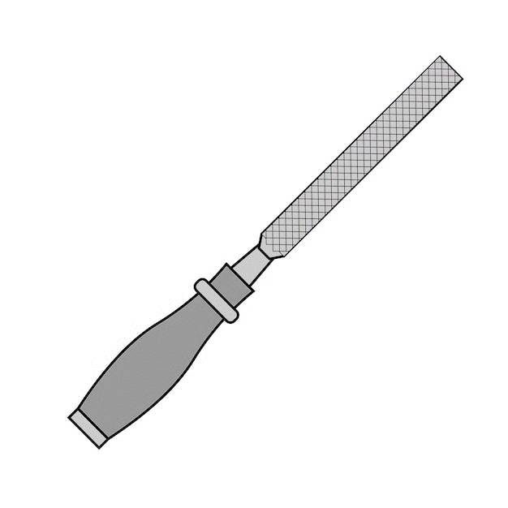
Figure 2.4: Hand File
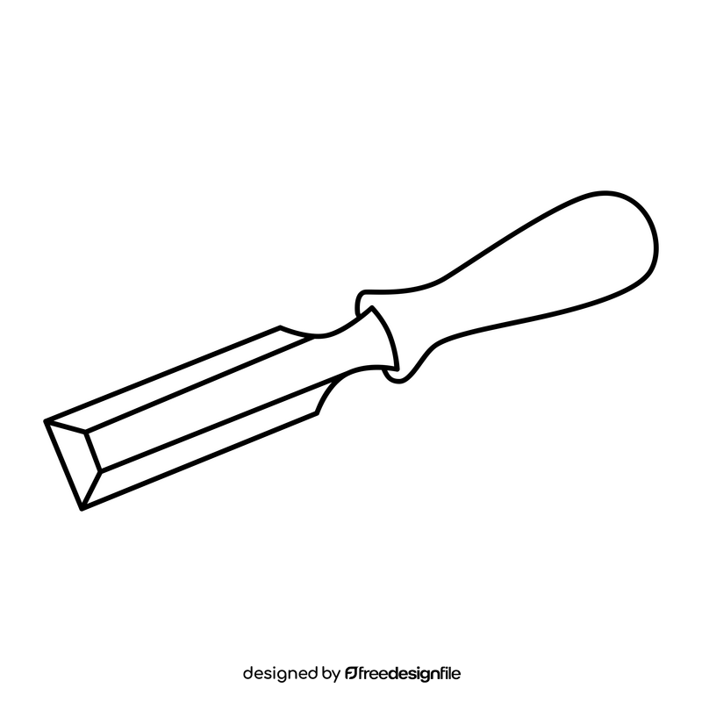
Figure 2.5: Chisel

CHAPTER THREE

3.1 Welding Operation
This is the process I used to cut or join two or more metals together with the application of gas and electric arc welding

3.1.1 Type of work carried out using oxy-acetylene
Oxy-acetylene can be used in welding various types of materials such as wire mesh in which it requires the application of brass and rod which serves as filler rod and gives the welding region strong binding forces. The brass rod should be dipped into flux to enable the brass rod easier to melt and flow to give a smooth surface finish. Other types of welding operation carried out using oxy-acetylene includes welding of components etc.
Metal-plate cutting operation was also accomplished using high temperature and a high pressure oxygen was introduced to blow out the molten metal and create the separation.

3.1.2 Procedure followed to cut a metal plate
- I marked the cutting line on the surface
- I set up the plate on the working table and allowed the place to be cut to hang over the table
- I lighted the flame with a spark lighter and adjusted for neutral pre heating flame.
- I positioned the pre-heat flame so that it matches with cutting line.
- When the metal is hot enough I slowly press the cutting lever.
- As cutting began fully I depressed the cutting and direct the low pipe along the cutting line with the nozzles at right so that it gives a good cutting.

3.1.3 Electric arc welding
Electric arc welding is a permanent joining method of two or more metals. I used the electric arc welding to join various metals together. Below are the steps on how I set up for electric arc welding.

3.1.4 Setting up for arc welding
- Firstly, I made sure that the welding machine was kept in a safe and comfortable place.
- I stretch out the twisted welding cables to the area I want to carry out the welding
- I checked the electrode holder whether the welding cable was properly fitted and tightened to the holder
- I checked whether the welding machine was properly connected to the electricity.
- I arranged the materials to be welded and kept them in a comfortable place
- I now kept the earth cable on the metal and started welding.

3.1.5 Drilling on the machine
Drilling on the machine is the machining process used to originate a hole to a required diameter using the machine.

3.1.6 Drilling of a 40mm diameter round work piece
- The 40mm diameter work piece was held firmly on a three-jaw chuck lathe machine
- An 18mm drill was selected and fixed correctly into the tail shock
- The lathe machine was ON, the headstock rotated with the work piece
- Then the drill was fed unto the center of the point to be drilled
- The drill was fed gradually unto the work piece as the tail stock spindle was turned to move in the drilling direction.
- Drilling of a blind and through hole was done the drilling process.

3.2 Fabrication of Fufu pounder
3.2.1 Tools/Materials
The fabrication of a fufu pounder involved using a variety of tools and equipment, including a welding machine, angle grinder, cutting torch, drill press, measuring tape and calipers, metal saw, sheet metal bender, hammer and anvil, vise, clamps, screwdrivers and wrenches, electric motor, lathe machine (if parts needed to be turned), and protective gear such as gloves, goggles, and a welding helmet.
3.2.2 Procedure
- Created detailed design plans and drawings for the fufu pounder, specifying dimensions and materials required.
- Selected appropriate materials (e.g., steel, aluminum) based on the design specifications.
- Cut materials to the required sizes using a metal saw or cutting torch.
- Welded the cut metal pieces to form the main frame of the pounder.
- Used clamps and a vise to hold pieces in place during welding for accuracy.
- Mounted the electric motor onto the frame securely.
- Connected the motor to the pounding mechanism (e.g., a reciprocating arm or rotating drum) using appropriate couplings or belts.
- Fabricated the pounding chamber using sheet metal, bending it into shape with a sheet metal bender.
- Ensured the chamber was strong and durable to withstand the pounding force.
- Assembled all parts, attaching the pounding mechanism to the motor.
- Installed any necessary shafts, bearings, and linkages.
- Wired the electric motor to a control switch and ensured proper electrical connections.
- Installed safety guards and emergency stops to ensure safe operation.
- Tested the fufu pounder to ensure it operated smoothly and efficiently.
- Made any necessary adjustments to the mechanism or motor settings.
- Cleaned and painted the fufu pounder to protect it from rust and corrosion.
- Performed a final inspection to ensure all components were securely attached and functioning properly.
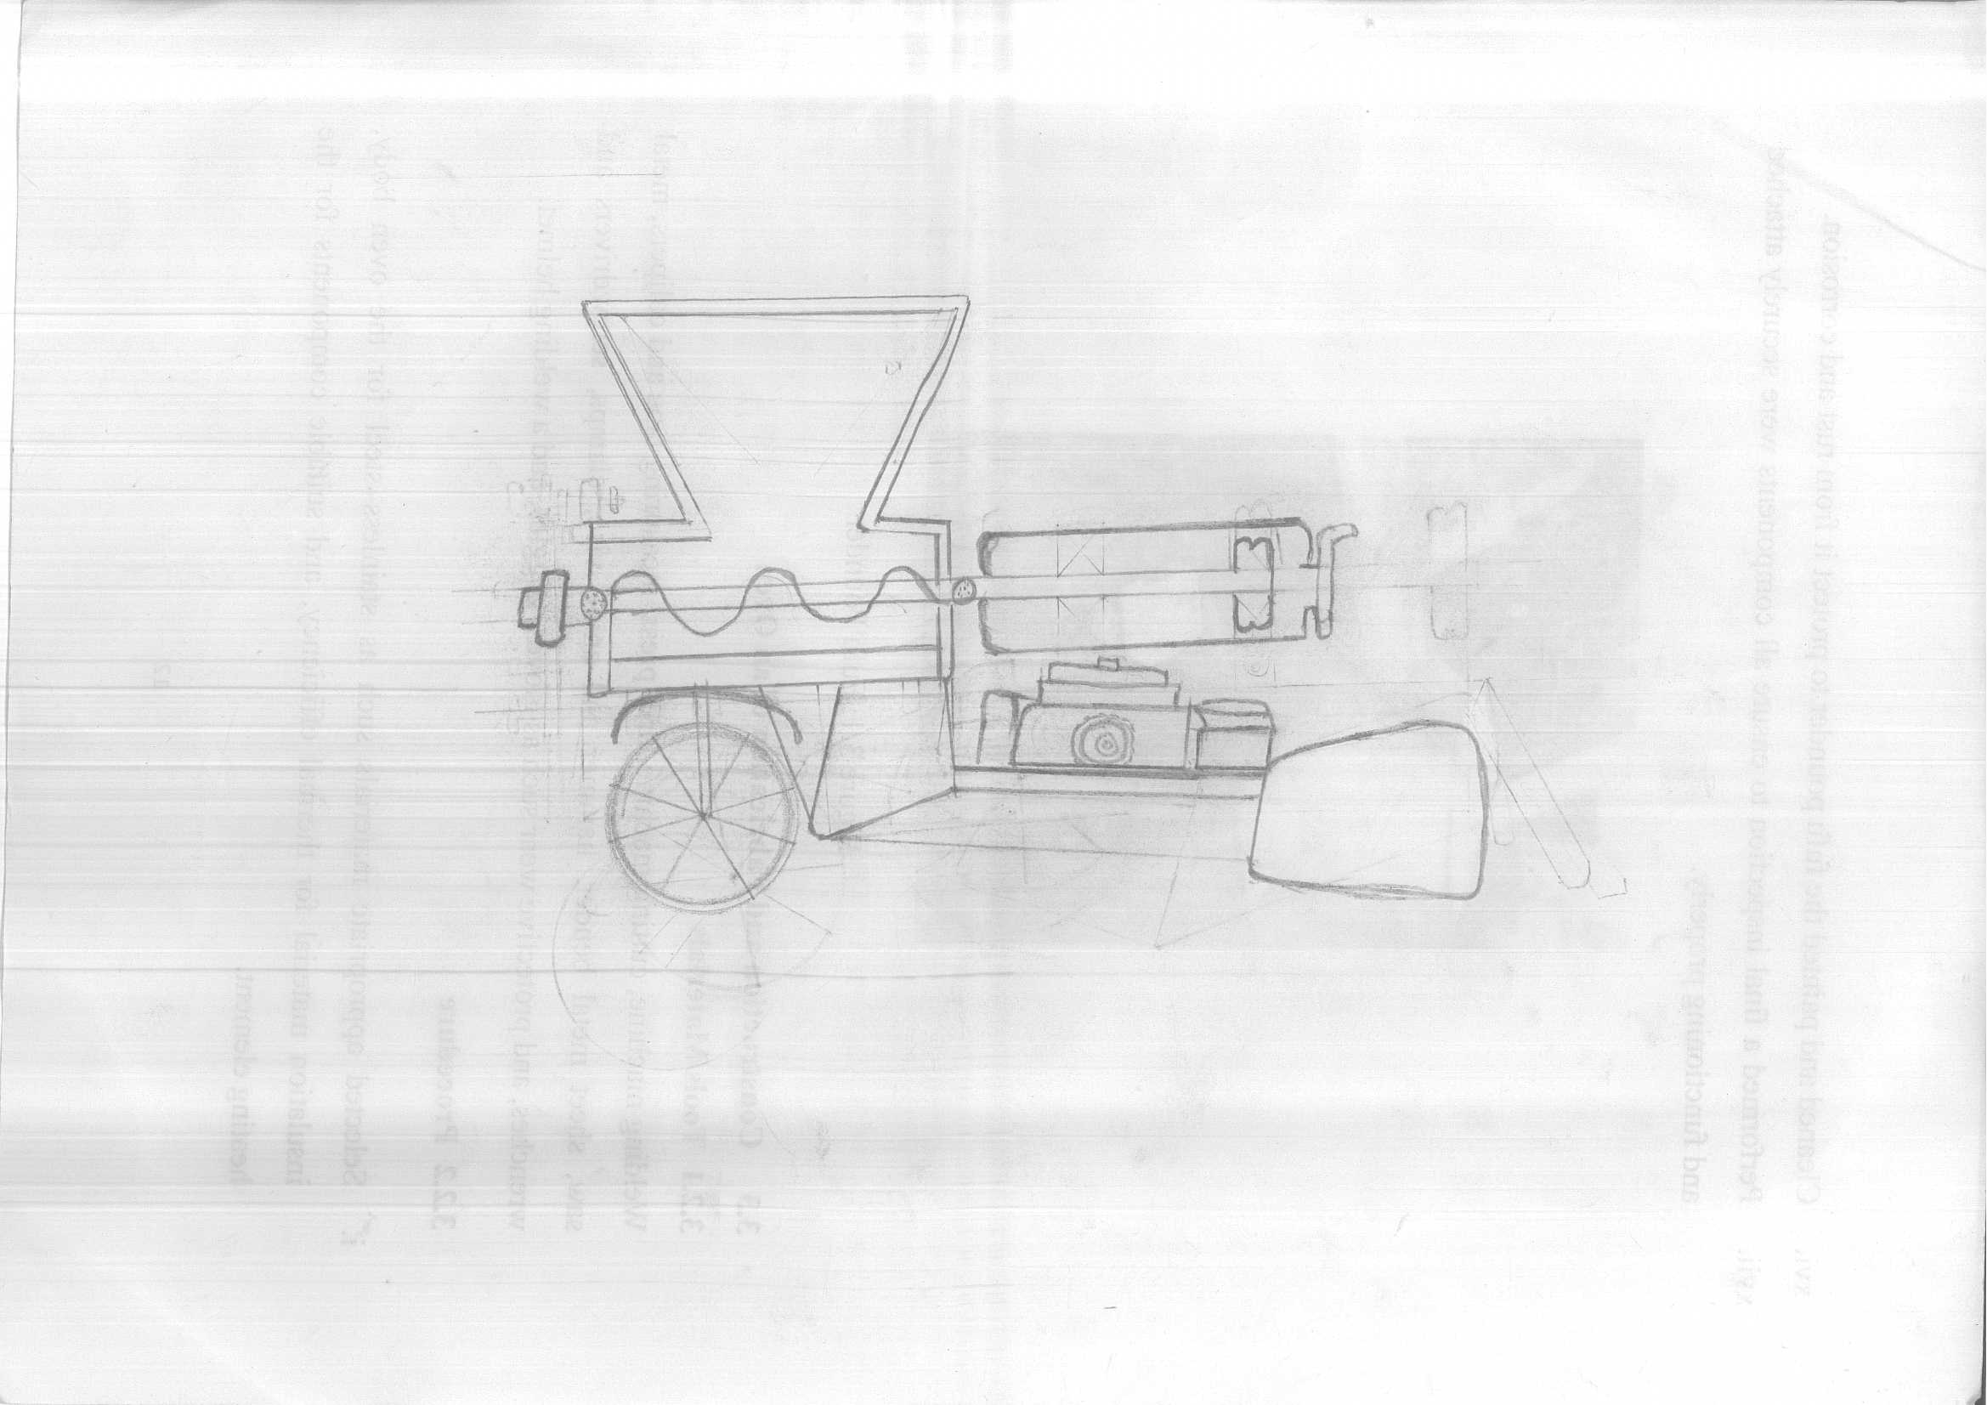
Figure 3.1: Fufu Pounder

3.3 Construction and Fabrication of an Oven
3.2.1 Tools/Materials
Welding machine, cutting machine, drill press, measuring tape and calipers, metal saw, sheet metal bender, hammer and anvil, vise, clamps, screwdrivers and wrenches, and protective wear such as gloves, goggles, and a welding helmet.
3.2.2 Procedure
  - Selected appropriate materials such as stainless steel for the oven body, insulation material for thermal efficiency, and suitable components for the heating element.
  - Cut the materials to the required sizes using a metal saw or cutting torch.
  - Welded the cut metal pieces to form the main frame of the oven.
  - Fabricated the outer body and inner chamber using sheet metal, bending and shaping them as necessary.
  - Installed insulation material between the outer body and the inner chamber to ensure thermal efficiency and safety.
  - Constructed the oven door, ensuring a tight seal to prevent heat loss. Installed hinges and a handle for easy operation.
  - Installed the heating elements, ensuring they were securely attached and evenly distributed to provide uniform heat.
  - Installed supports for racks and trays inside the oven, ensuring they were adjustable and could withstand high temperatures.
  - Assembled all parts, attaching the inner chamber, outer body, door, and heating elements.
  - Installed any necessary shafts, bearings, and linkages if the oven included rotating racks.
  - Tested the oven to ensure it operated smoothly and efficiently, reaching and maintaining the desired temperatures.
  - Cleaned and painted the oven to protect it from rust and corrosion.
  - Performed a final inspection to ensure all components were securely attached and functioning properly.
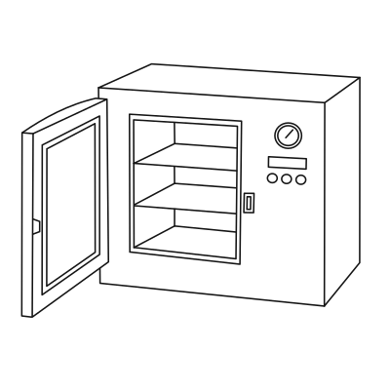
Figure 3.2: Fabrication of an Oven

3.4 Construction of Window Protector
3.4.1 Tools/Materials
The necessary tools included a welding machine, angle grinder, cutting torch, drill press, measuring tape and calipers, metal saw, sheet metal bender, hammer and anvil, vise, clamps, screwdrivers and wrenches, and protective gear such as gloves, goggles, and a welding helmet.
3.4.2 Procedure
- All necessary materials and tools for the welding process were gathered, including the burglary-proof panels, welding machine, welding electrodes, protective gear (welding helmet, gloves, safety glasses), and any additional accessories.
- The surfaces to be welded were cleaned and freed from rust, paint, or any other contaminants.
- The burglary-proof panels were properly aligned to ensure they fit securely together and formed a strong joint. Clamps or magnets were used to hold the panels in place during welding.
- Tack welds were performed at key points along the joint to temporarily secure the panels in place. These tack welds helped prevent the panels from shifting or moving during welding.
- The welding machine was used to perform the main welding passes along the entire length of the joint.
- The appropriate filler material was chosen based on the type of metal being welded and the welding process used.
- After completing the welding process, the welds were inspected for any defects or imperfections.
- The welded joints were allowed to cool down gradually to avoid introducing stress or distortion.
- A visual inspection of the welded joints was performed to ensure they met the required quality standards.
- A protective coating or paint was applied to the welded joints to prevent corrosion and enhance the longevity of the burglary-proof structure.
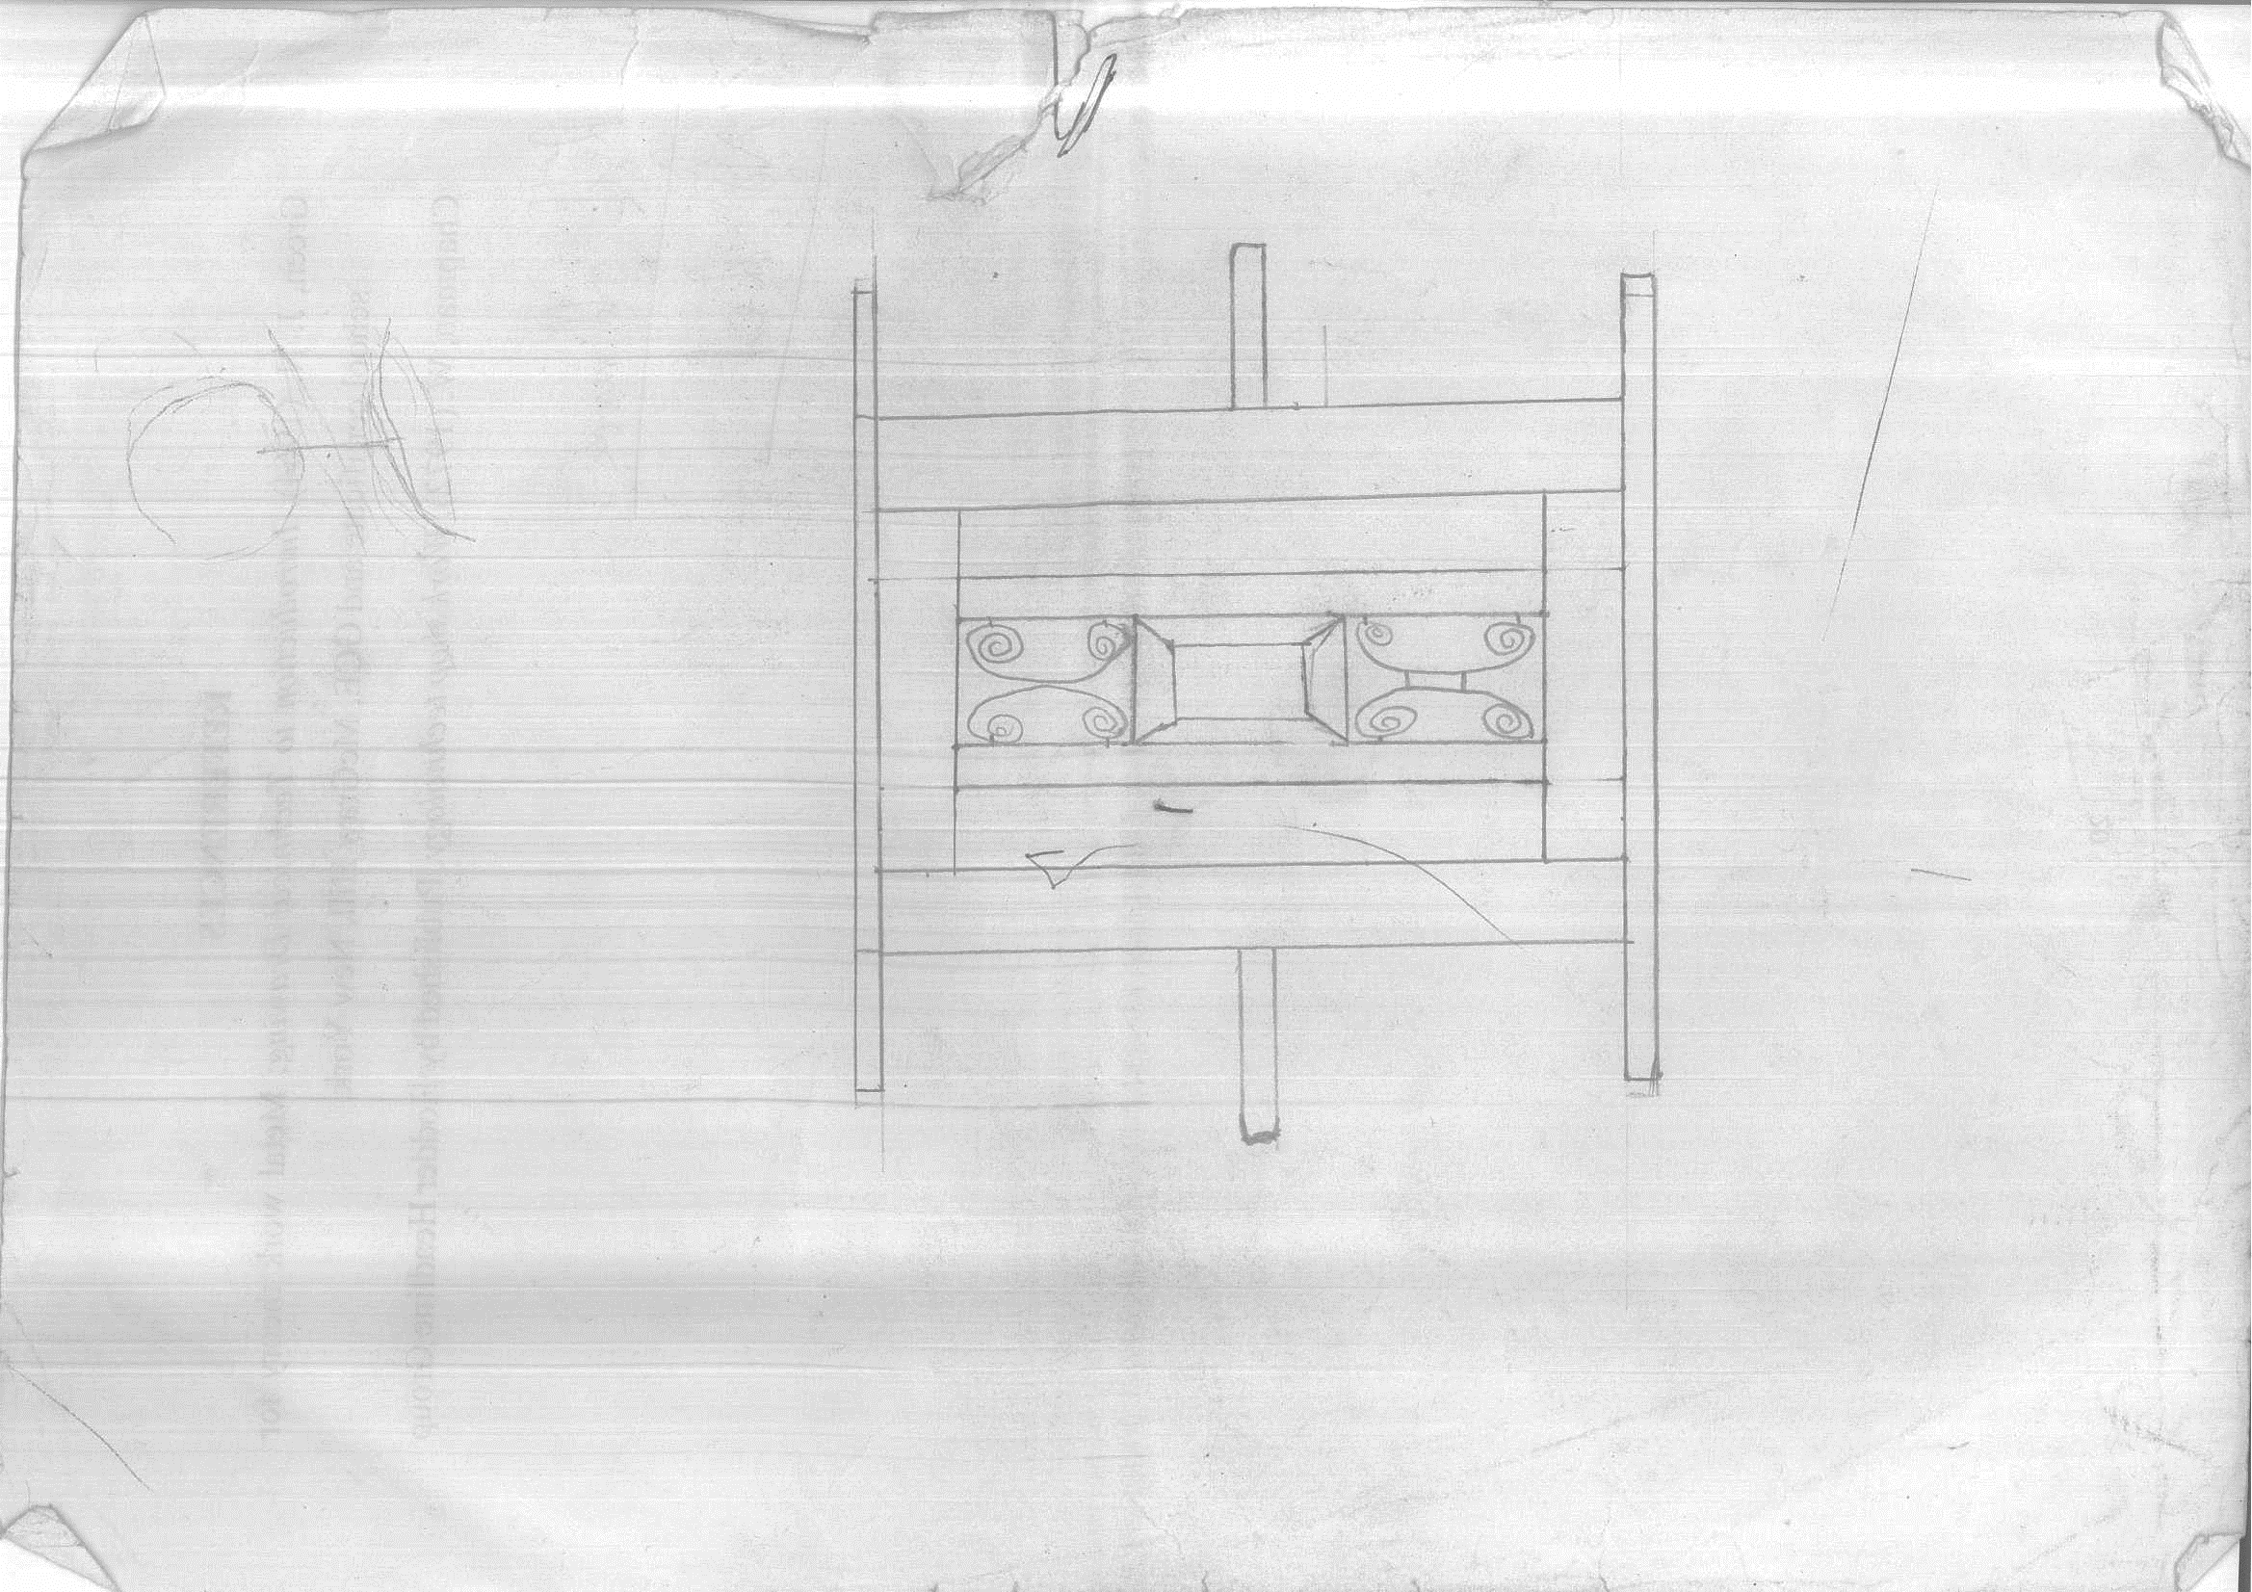
Figure 3.3: Window protector

3.5 Construction and Fabrication of Rice Thresher
3.5.1 Tools/Materials
A welding machine, angle grinder, cutting torch, drill press, measuring tape and calipers, metal saw, sheet metal bender, hammer and anvil, vise, clamps, screwdrivers and wrenches, electric motor, bearings and shafts, and protective gear like gloves, goggles, and a welding helmet.
3.5.2 Procedure
- Selected suitable materials such as steel for the frame and components, and bearings for moving parts.
- Cut materials to the required sizes using a metal saw or cutting torch.
- Welded the cut metal pieces to construct the main frame of the rice thresher.
- Used clamps and a vise to ensure precise alignment during welding.
- Assembled the threshing drum and concave components, ensuring they were securely attached to the frame.
- Installed bearings and shafts to support and facilitate movement of the threshing components.
- Mounted the electric motor onto the frame, ensuring it was securely attached and aligned with the threshing components.
- Connected the motor to the threshing drum using appropriate belts or chains for power transmission.
- Tested the rice thresher to ensure all components operated smoothly and efficiently.
- Installed safety guards around moving parts to prevent accidents.
- Conducted operational checks to verify proper functionality and safety features.
- Cleaned and painted the rice thresher to protect it from rust and corrosion.

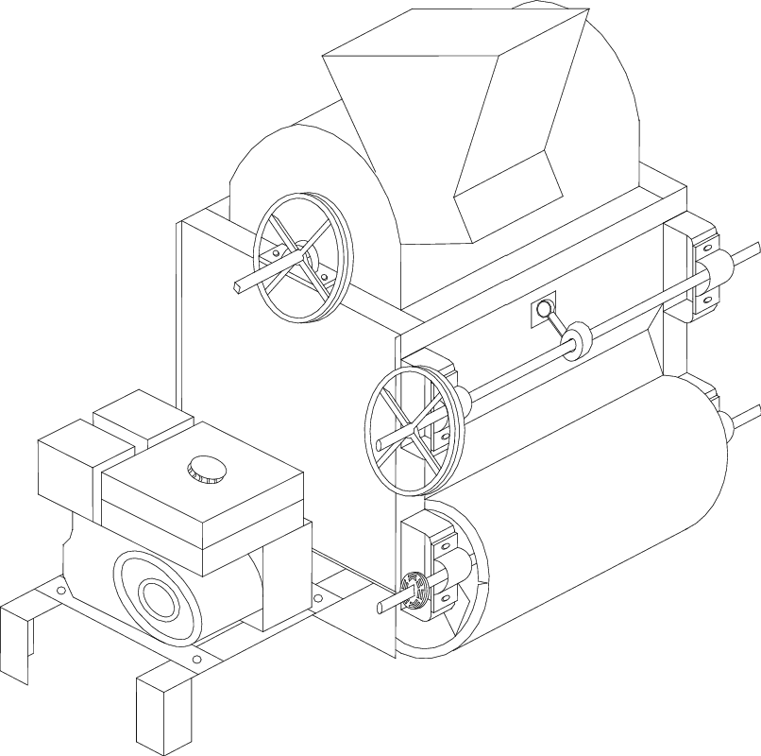
Figure 3.5: Rice thresher machine

CHAPTER FOUR

CONCLUSION AND RECOMMENDATION

4.1 Conclusion
SIWES is an important process of equating the future. It exposes the student to practical of their class lectures, in other to bridge the gab.it also provides accurate and comprehensive assessment of the award of national diploma (N.D)
Through this training, one will realize the big difference between academic exercise practical and real-life experience. The exercise has enable me the opportunity to see, feel and practice In the area of my discipline.

4.2 Recommendation
Students do suffer during their attachment therefore; the allowance should be given to them by the establishment where the students is doing the industrial training (IT) and also by the industrial training fund (ITF) should be paid immediately they are through with the industrial training (IT).
They should also try their best to have connections with some companies so that during the period of SIWES their students can be divided to attach with them.

REFERENCES
Ashcroft, W. & Mermin, N. David (2016). Solid state physics. New York: Holt, Rinehart and Winston. ISBN 978-0-03-083993-1.
Callister, D. (2017). Materials science and engineering: an introduction (4th ed.). New York: John Wiley & Sons. ISBN 978-0-471-13459-6.
Chapman, W. (2012). Work shop technology. Published by Hodder Headline Group
Kittel, C. (2018). Introduction to solid state physics. Paul McEuen (Global edition, [9th edition] ed.). Hoboken, NJ: Wiley. ISBN 978-1-119-45416-8.

